**DAILY ONLINE ACTIVITIES SUMMARY**

|  |  |  |  |  |  |  |  |  |
| --- | --- | --- | --- | --- | --- | --- | --- | --- |
| **Date:** | **02/06/2020** | | | | | **Name:** | **Rahul J** | |
| **Sem & Sec** | **8th sem B sec** | | | | | **USN:** | **4AL16CS130** | |
| **Online Test Summary** | | | | | | | | |
| **Subject** | | **No Test Conducted** | | | | | | |
| **Max. Marks** | | **--** | | **Score** | | | **--** | |
| **Certification Course Summary** | | | | | | | | |
| **Course** | **Step into Robotic Process Automation**  **And cloud foundations** | | | | | | | |
| **Certificate Provider** | | | **UI Path and great learning** | | **Duration** | | | **4 Hours and 4.5hours** |
| **Coding Challenges** | | | | | | | | |
| **Problem Statement:**  **Write a C Program to find inversion count of array** | | | | | | | | |
| **Status: Solved** | | | | | | | | |
| **Uploaded the report in Github** | | | | | **Uploaded** | | | |
| **If yes Repository name** | | | | | **Rahul_j** | | | |
| **Uploaded the report in slack** | | | | | **Yes** | | | |

Online Test Details: (Not conducted)

Certification Course Details:

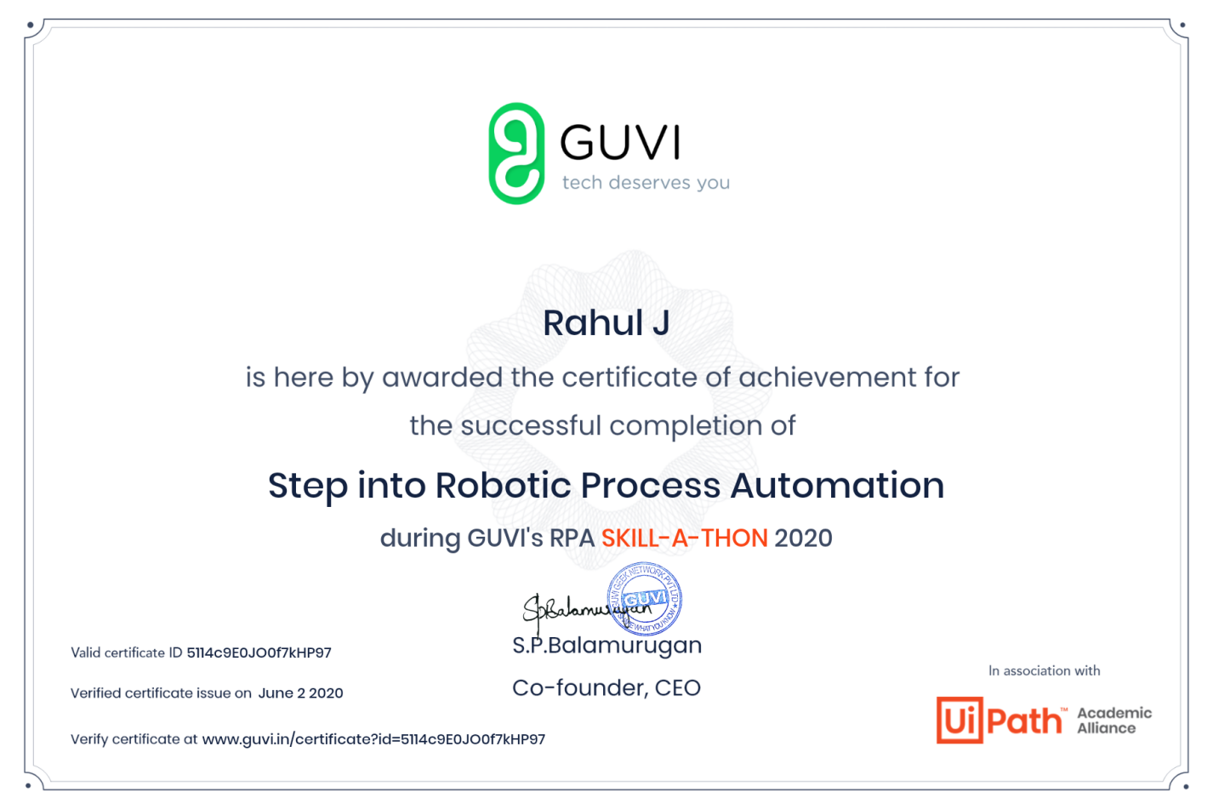

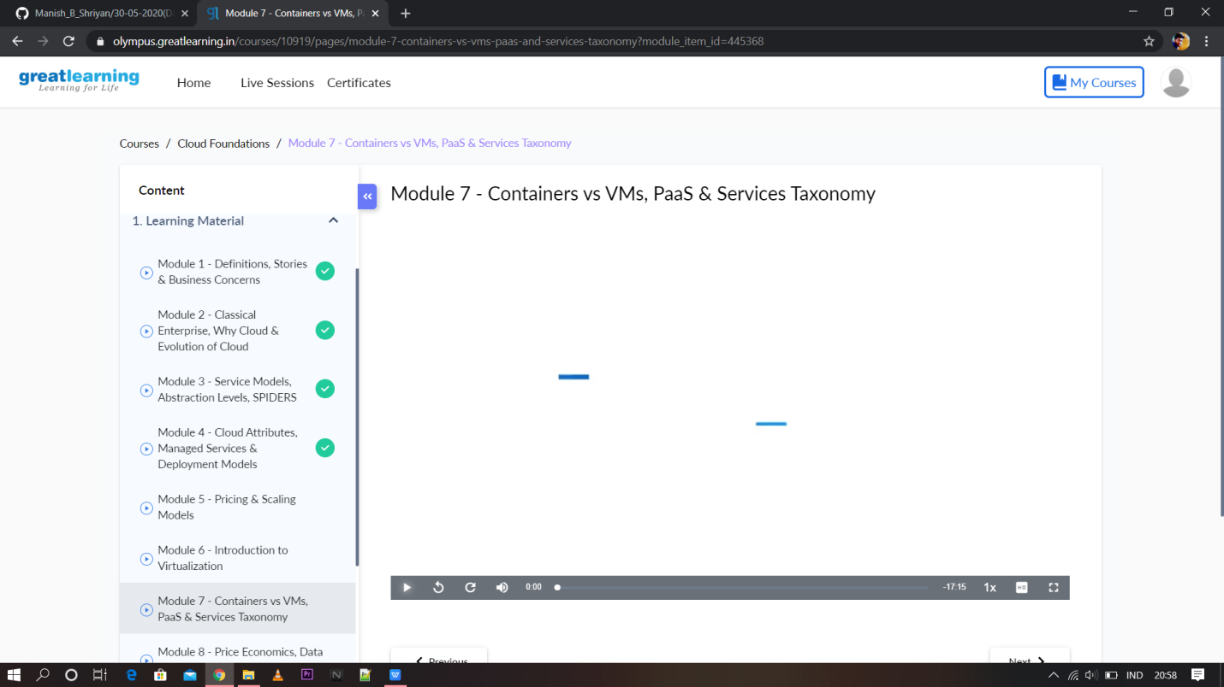

Coding Challenges Details:

|  |
| --- |
|  |
|  |  |
|  |  |
|  |  |
|  |  |
|  |  |
|  |  |
|  |  |
|  |  |
|  |  |
|  |  |

#include<stdio.h>

int getInvCount(int arr[], int n)

{

int inv_count = 0;

for (int i = 0; i < n - 1; i++)

for (int j = i + 1; j < n; j++)

if (arr[i] > arr[j])

inv_count++;

return inv_count;

}

int main(int argv, char** args)

{

int arr[] = { 2,4,1,3,5 };

int n = sizeof(arr) / sizeof(arr[0]);

printf(" Number of inversions are %d \n", getInvCount(arr, n));

return 0;

}

|  |
| --- |
|  |
|  |  |
|  |  |
|  |  |
|  |  |
|  |  |
|  |  |
|  |  |
|  |  |
|  |  |
|  |  |